Solar Power Tree Design in Tourist Village Area in Situgede Village, Karangpawitan Subdistrict, Garut Regency

M. GILANG PRAWIRA¹, TEGUH ARFIANTO²,
^{1,2}Electrical Engineering Departement
National Institute of Technology Bandung
Email : muhgilangpra22@gmail.com

Received 30 November 201x | Revised 30 Desember 201x | Accepted 30 Januari 201x

Abstract
Energy is a basic need of every human being in the world, even in Indonesia though. Situgede Village is a village located in Karangpawitan Subdistrict, Garut District. In the design concept of the Situgede village as a tourist village, the Situgede Village will be built a solar power plant. In the construction of solar power plants that will be built, will be made with the concept of Solar Tree Power. The design methods start from calculating the total load estimation, calculating battery capacity, determining the peak wattage value of the PV module, determining the inverter, determining the SCC, to designing the physical power of the Solar Power Tree. Until the design, this Solar Power Tree with a capacity of 2 kWh with a total estimated load of 1896 Wh.
Keywords: Power Plant, Solar cell, Solar Tree, Design, Alternative Energy

1. introduction
Energy is the basic need of every human being in the world, even in Indonesia. In Indonesia, the energy needs that are currently often used are energy sourced from fossil fuels. Until 2018 the utilization of energy sourced from fossil fuels reached 86%, while the utilization of new and renewable energy reached 14%. It can be seen from the data if power plants in Indonesia itself are still dependent on fossil fuels (Outlook Energi, 2019).
One of the potential utilizations of new and renewable energy in Indonesia is to utilize solar energy. Indonesia is located on the equator where at the equator, the area on the line will get more solar irradiation potential than areas that are not on the equator, so the potential for solar energy in Indonesia is quite high. The potential of solar energy in Indonesia reaches an average of 4.8 kilowatt hours per square meter per day (National Energy Council 2016). In another journal, Indonesia has an average solar energy potential of 5 kwh / m2 / day (Meitarumbayan, 2016).
Situgede village is a village located in Karangpawitan Subdistrict, Garut Regency. Located 16 km from the city of Garut, Situgede village is a village that will be used as a tourist village by the Ministry of Villages, Development of Disadvantaged Regions, and Transmigration of the Republic of Indonesia. In the concept of designing Situgede village as a tourist village, Situgede Village will be built a power plant with pikohydro and solar power. In the construction of a solar power plant to be built, it will be made with the concept of Solar Tree Power. The purpose of this research is to design Solar Tree Power and determine the specifications of Solar Tree Power designed, for the tourist village area in Situgede Village, Karangpawitan Subdistrict, Garut Regency.

2. methodology

2.1 Design of Solar Power Tree System
In this study, the system design process began from regional observation, load estimation calculation, to the design of the Solar Power Tree. Figure 1 here illustrates the block diagram of the Solar Power Tree designed.

Figure 1. Solar Power Tree Design Diagram Block
Based on Figure 1, the first thing done in the design of solar power tree is regional observation, regional observation was done in Situgede Village, Karangpawitan District, Garut Regency (-7.2ºN / 108.0ºE, 753 m). The data that must be obtained is data on the potential of solar irradiation energy (Wh / m2) and load estimation data. Then after getting regional observation data, it can be calculated the estimated load in a month with the following formula:
$Estimated total load a month = 30 days × Estimated daily load$ (3)
After, the estimated total load of a month we already know, then the next is to do the calculation of solar power tree specifications, after getting the results of the calculation it can be simulated on PVsyst, so that the results can be made design for solar power tree. Then, the specifications of Solar Power Tree calculations include:
- Determine System Voltage
In determining the voltage of the system, it does not require calculations, but looks from the basis of the requiment of the system the electrical equipment is needed (Nissar & Ahmad, 2017).

- Determine The size of The PV Array
In determining the large PV array, the formula is used as follows:
${PV}_{ array size}=\frac{1}{η_{baterai}× η_{SSC}×η_{wiring}}$ (2)
So that it can be determined the value of Energy (E) in the array can be obtained from the formula:
$E_{array}= E_{a}×{PV}_{ array size}$ (3)

- Determine Total PV Array Current
Total pv array (I_{DC}) flows can be determined by:
$I_{DC}=\frac{W_{peak}}{V_{DC}}$ (4)
Dimana W_{peak} dapat diperoleh dari rumus :
$W_{peak}= \frac{P_{array}}{Length of time irradiation}$ (5)

- Determine Wpeak on PV Array
In determining W_{peak} on the required panel, it can be seen from the value of W_{peak} on the calculation, then divide it with the planned panel.

- Determine Battery Size
In determining the size of the battery to be used, the formula is used:
$Total DC load requirement= \frac{P_{array}}{System Voltage}$ (6)
Since the system can run without sunlight (autonomous), then we can calculate the capacity of the battery with the formula:
$Autonomous battery capacity=Autonomous day×The total load needs of DC$ (7)
Battery capacity required based on DoD and Efficiency Needs with the formula:
$Battery capacity= \frac{Autonomous battery capacity}{Efficiency of Battery ×DoD}$ (8)

- Determinine Inverter Capacity
The size of the inverter should match the average load and peak load that operates for more than 30 minutes. The estimated or measured load profile should be established to identify continuous load and peak load. The capacity (rating) of the inverter should not be higher than the capacity of the photovoltaic module.

- Determine the Solar Charge Controller Capacity
In determining the capacity of the Solar Charge Controller can be determined, based on the value of Wpeak that has been calculated, then look for SCC marketed with W_{peak} capacity.

2.2 Testing Methods
To test the Solar Power Tree, then simulate the design in PVSyst. PVsyst is software created to analyze a solar power generation system, either in off-grid or on-grid design. It is recommended to use PVsyst with the latest version. The version of PVsyst software used is PVSyst version 6.81. Then after being simulated it can be analyzed so that it can be made a design of the Solar Power Tree.

3. Results and Discussion
From solar power tree testing in PVSyst obtained data as in Table 1.
Table 1. Simulation results on PVSyst
Bulan | Globhor  kWh/m² | GlobEff  kWh/m² | E_Avail  kWh | Eunused  kWh | E_miss  kWh | E_user  kWh | E_Load  kWh | SolFrac  kWh
Januari | 123,8 | 113,4 | 92,2 | 30,97 | 0,000 | 58,78 | 58,78 | 1,000
Februari | 121,1 | 113,3 | 91,9 | 34,42 | 0,628 | 52,46 | 53,09 | 0,988
Maret | 134,1 | 128,8 | 103,4 | 42,39 | 0,000 | 58,78 | 58,78 | 1,000
April | 136,1 | 136,6 | 109,5 | 48,34 | 0,000 | 56,88 | 56,88 | 1,000
Mei | 143,5 | 148,6 | 119,3 | 56,28 | 0,040 | 58,74 | 58,78 | 0,999
Juni | 135,7 | 142,8 | 116,6 | 56,19 | 0,000 | 56,88 | 56,88 | 1,000
Juli | 130,7 | 135,7 | 110,3 | 48,90 | 0,000 | 58,78 | 58,78 | 1,000
Agustus | 143,9 | 145,5 | 118,1 | 54,59 | 0,000 | 58,78 | 58,78 | 1,000
September | 142,7 | 139,8 | 112,6 | 52,45 | 0,235 | 56,65 | 56,88 | 0,996
Oktober | 144,0 | 136,8 | 109,6 | 49,52 | 2,336 | 56,44 | 58,78 | 0,960
November | 166,3 | 153,0 | 124,8 | 64,33 | 0,000 | 56,88 | 56,88 | 1,000
Desember | 134,8 | 122,8 | 100,7 | 40,40 | 2,040 | 56,74 | 58,78 | 0,965
Tahunan | 1656,7 | 1617,0 | 1309,0 | 578,79 | 5,280 | 686,76 | 692,04 | 0,992

From Table 1 there are 8 columns, consisting of GlobHor columns, in the form of data on the potential of solar energy in 12 months, this data can be obtained from NASA, Meteonorm, and direct measurements on the spot. GlobEff column containing data on the potential of solar energy is effective due to shading due to environmental and climate. A column E_Avail that contains energy data available in a region. The EUnused column contains data in the form of energy available in the PV array, when the battery is full. The E_miss column contains energy data lost when the grid is not there and the battery is empty. The E_User column contains data about the energy supplied by the plant to the load. The E_Load column contains data about the energy the load requires. And lastly there is the SolFrac column which contains comparative data between the energy supplied to the load with the energy required by the load.
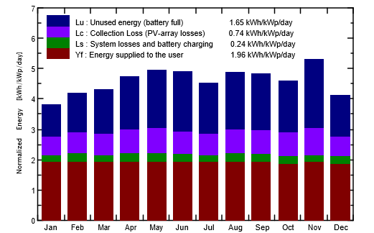
Figure 2. Normalized productions graph
From the graph shown by Figure 2, showing normal production on the Solar Power Tree for a year. From the graph there is Lu (unused energy) which shows energy that is not used when the battery is in full condition which averages 1.65 kWh / kWp / day. Then there is Lc (collection loss) which shows the magnitude of the loss in the average PV array of 0.74 kWh / kWp / day. Then there are Ls (system losses and battery charging) which shows losses on the system and power usage for charging batteries which average 0.24 kWh / kWp / day and lastly there is Yf (Energy supplied to user) which shows the amount of energy supplied to the average load of 1.96 kWh / kWp / day.
From the graph addressed to Figure 2 and Table 1, what needs to be considered is the E_Miss column and the EUnused column, in the column E_Miss as discussed earlier, contains less energy data due to the energy supplied no more than the energy required by the load, so that the data in the column must be zero. So that the value in the E_Miss column can be zero, usually in the design of the wp value in the PV Array is enlarged or if it cannot be done then, in the estimated load it needs is reduced again, until the value in the column E_Miss can be zero. In addition, when the Wp value on the PV Array is enlarged too large, as a result the solar power tree is designed it will produce a value on the large EUnused column, so the system wastes too much energy.
Table 2. Solar Power Tree Specifications
System Voltage | 48 V_{DC}
Energy size PV Array | 2411,712 Wh
Total of Current PV array | 8,374 A
Number of Array | 6 Array
W_{peak} in PV Array | 160 W_{p}
Battery Size | 139,11 Ah
Inverter Capacity | Rated capacity | 1500VA
Inverter Capacity | Rated power load | 1000W
Inverter Capacity | Input | DC input | DC 10,5-15V (12V)/ DC 21-30V (24V)
Inverter Capacity | Input | AC input | 190-275V AC
Inverter Capacity | Input | Frequency | 50Hz/ 60Hz±5% (Auto)
Inverter Capacity | Output | Voltage | 110V/ 120V/ 220V/ 230V/ 240V AC
Inverter Capacity | Output | Frequency | 50Hz/ 60Hz±5% (Auto)
Inverter Capacity | Output | Wave form | Pure sine wave
Inverter Capacity | Output | Transfer efficiency | ≥85% (full load)
Solar Charge Controller Capacity | Charging Current |  | 10 Amp
Solar Charge Controller Capacity | Battery Voltage: |  | 12V
Solar Charge Controller Capacity | Maximum supported panel: |  | 200Wp

Dari Tabel 2, spesifikasi Solar Power Tree yang dirancang, Solar Powe Tree ini dapat digunakan oleh untuk beban yang rendah. Dengan tegangan sistem sebesar 48 V, arus yang dihasilkan sebesar 8,374 A dan Wpeak pada array sebesar 160 Wp maka dapat di desain Solar Power Tree dengan desain seperti Gambar 3 berikut ini:
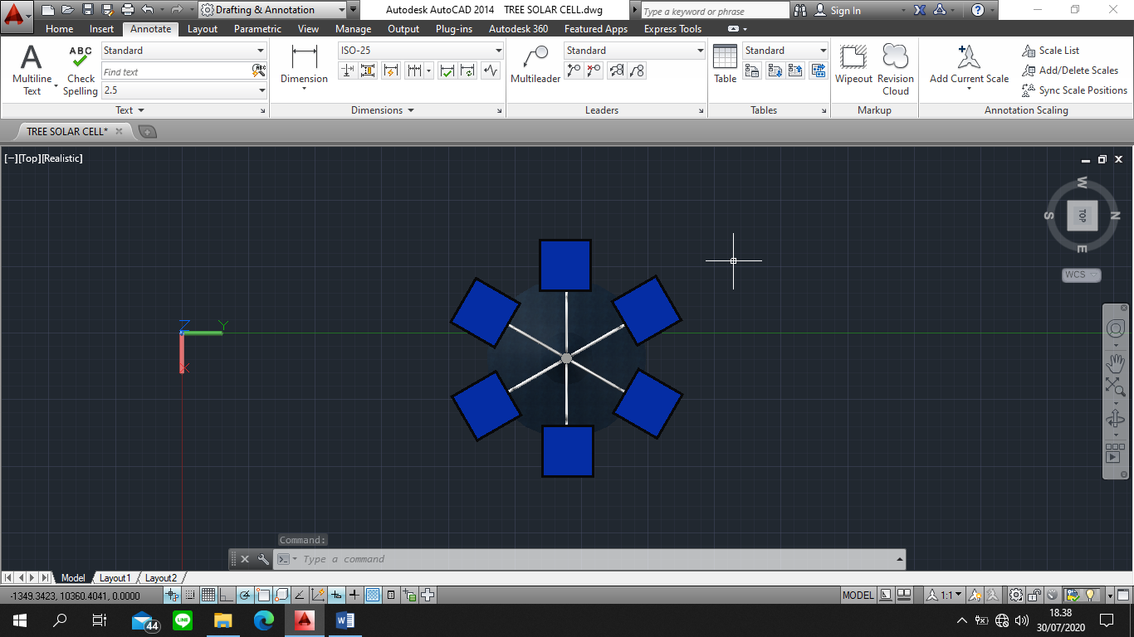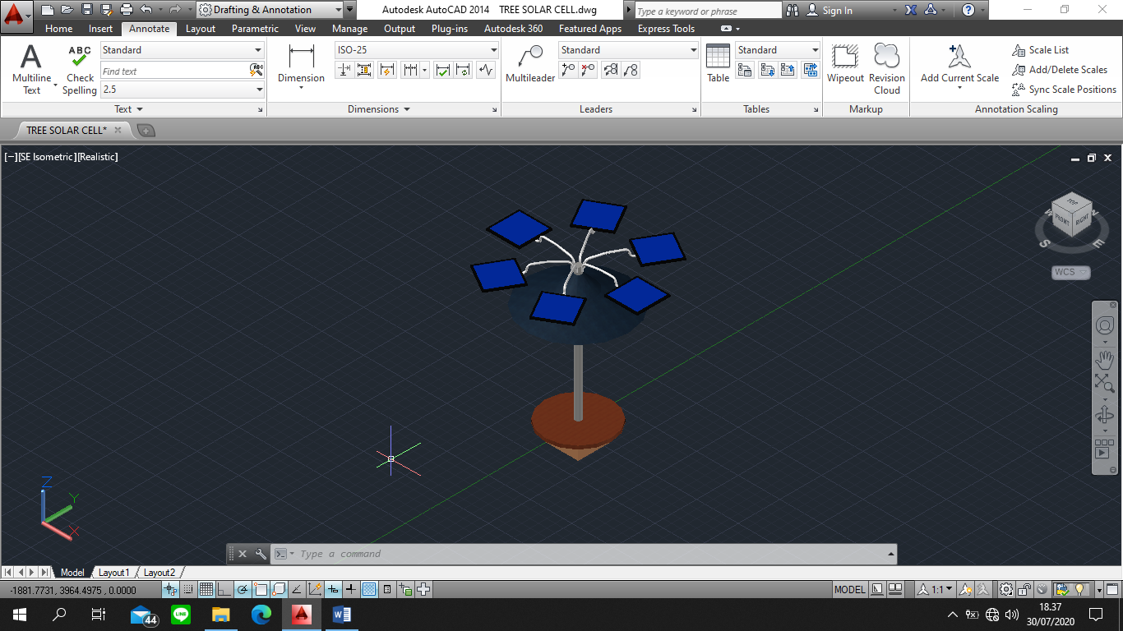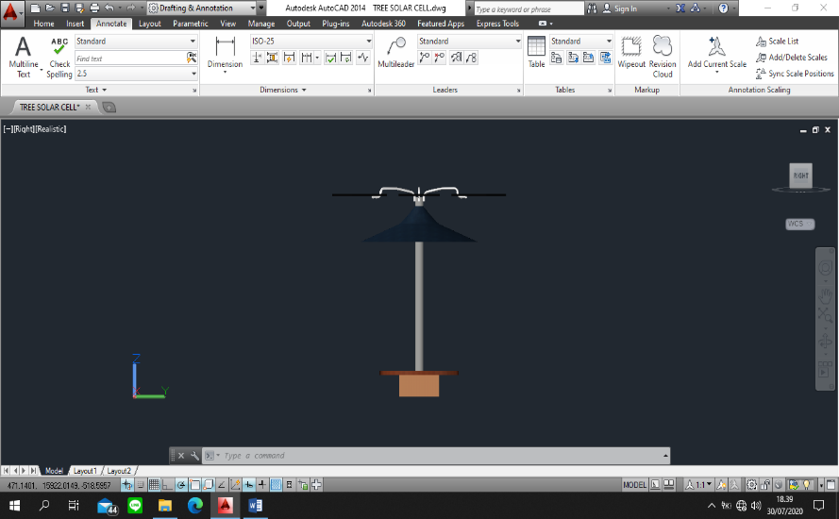
Figure 3. Solar Power Tree construction design.
Based on the design of Solar Power Tree for tourist village areas, the Solar Power Tree is designed as high as 3 meters to get more optimal sunlight and overcome the problem of shading by trees and especially in order to become an icon of the tourist village, has 6 PV Array panels of 1 m² each with a Wp value that has been calculated at 160 Wp and there is a 3 m² umbrella for shelter from hot weather and rain, What's more, it can protect the power house that will be planned under the table. Then there is a table mat of 2 m² to store something and can also be used as a communal place for visitors, facilitated also a place for charging mobile phones. Battery, Inverter and SCC will be stored under the table

4. CONCLUSIONS
From the results of the solar power tree design for the tourist village area in Situgede Village, Karangpawitan Subdistrict, Garut Regency, it can be concluded that, in achieving the design with an estimated load of 1896 Wh for a day, and amounting to 56.88 kWh in a month. Then solar power tree with 6 PV array with wp value in PV array is needed by 160 Wp. with the required inverter capacity of 1 kW, with inverter used is an inverter ATO-OGI-1500. Then, with the required SCC capacity of 10 A with SCC used is Solar Charge Controller - SCC1210NM and battery capacity required of 139,111 Ah

aCKNOWLEDGEMENT
The author would like to express his deepest gratitude for the village head and the community of Situgede, Karangpawitan Subdistrict, Garut Regency for being allowed to conduct a location survey.

LIST OF REFERENCES
Hasan, Hasnawiya. (2012). Perancangan Pembangkit Listrik Tenaga Surya Di Pulau Saugi. Universitas Hasanuddin
Mayfield, R. (2010). Photovoltaic Design & Instalation. Wiley Publishing, Inc. ISBN : 978- 0-470-59893-1.
Mermoud, Andre & Bruno Witmerr (2017). PVSYST 6. PVSYST Team.
Muminovic, Adits dkk. (2014). Implementation of the Project “Solar tree” in Sarajevo. University of Sarajevo, Sarajevo, Bosnia and Herzegovina
Nissar, Mohd & Aziz Ahmad. (2017). Solar Power Tree - An Artistic Design. Al- Falah University, Faridabad, India
Quasching, V. (2005). Understanding Renewable Energy Systems. EARTSCAN London. ISBN : 1-84407-128-6.
Ramadhani, Bagus. (2018). Instalasi Pembangkit Listrik Tenaga Surya Dos & Don’ts. Direktorat Jenderal Energi Baru, Terbarukan dan Konservasi Energi
Rumbayan, Meita dkk. (2012). Mapping of Solar Energy Potential in Indonesia Using Artificial Neural Network and Geographical Information System. Tokyo University.
Surhayati, dkk. (2019). Indonesia Energy Outlook 2019. Sekjen Dewan Energi Nasional.
Yuniarti, Nurhening & Eko Prianto. (2015). Pengantar Pembangkit Tenaga Listrik. Universitas Indonesia

