Hasil Simulasi Atoll Pada Penelitian “Perancangan Dan Analisis Pemanfaatan Frekuensi 850 Mhz Pada Teknologi LTE Advanced Untuk Meningkatkan Penetrasi Mobile Broadband Di Indonesia” oleh Ade Wahyudin, Muntaqo Alfin Amanaf, ita k. Ratnasari

1. Reference Signal Received power

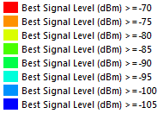
Gambar1. Legenda parameter simulasi RSRP
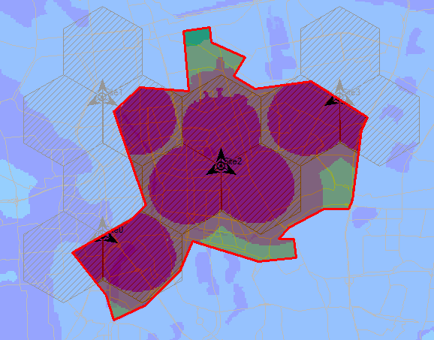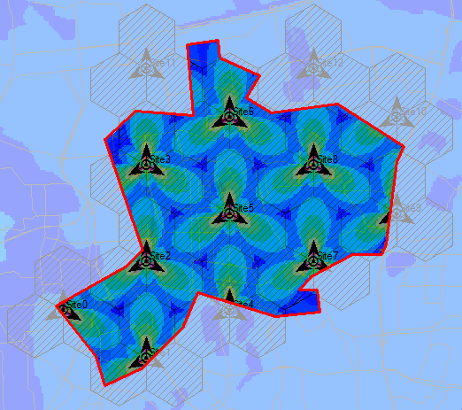
Gambar2. Hasil simulasi RSRP kota Jakarta Pusat; LTE-A 850MHz (kiri), LTE 1800MHz (Kanan)
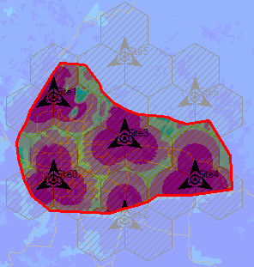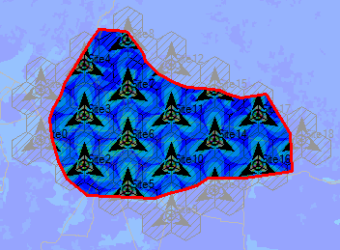
Gambar 3. Hasil simulasi RSRP kota Bandung; LTE-A 850MHz (kiri), LTE 1800MHz (Kanan)
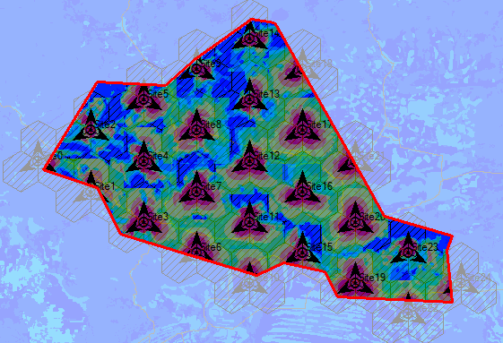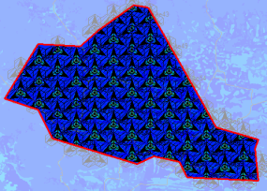
Gambar 4. Hasil simulasi RSRP Kabupaten Banyumas; LTE-A 850MHz (kiri), LTE 1800MHz (Kanan)
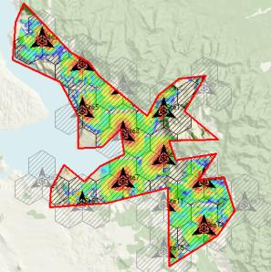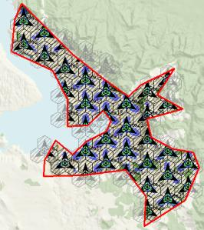
Gambar 5. Hasil simulasi RSRPKabupaten Toba Samosir; LTE-A 850MHz (kiri), LTE 1800MHz (Kanan)

- Carrier Signal to Interference + Noise Ratio

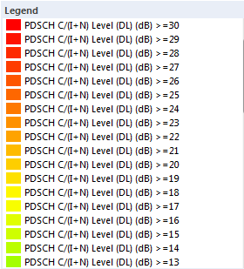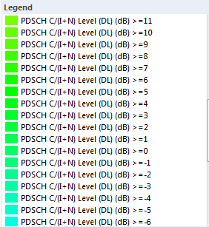
Gambar 6. Legenda parameter CINR
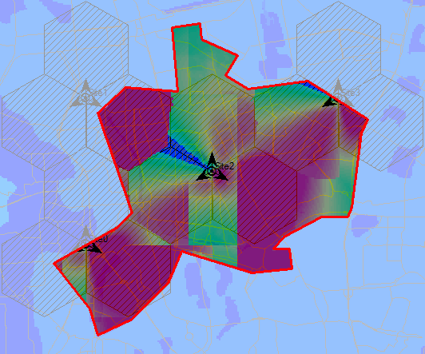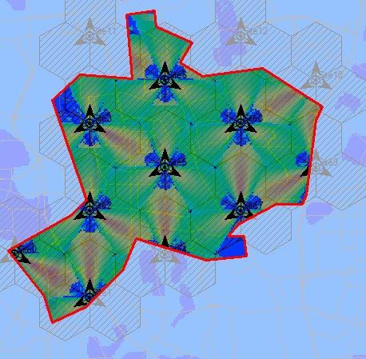
Gambar 7. Hasil simulasi RSRP kota Jakarta Pusat; LTE-A 850MHz (kiri), LTE 1800MHz (Kanan)
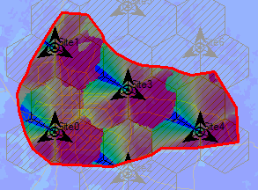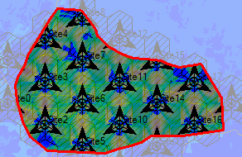
Gambar 8. Hasil simulasi RSRP kota Bandung; LTE-A 850MHz (kiri), LTE 1800MHz (Kanan)
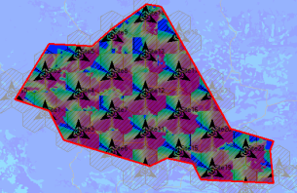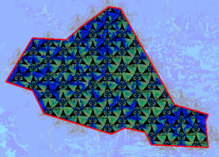
Gambar 9. Hasil simulasi RSRP Kabupaten Banyumas; LTE-A 850MHz (kiri), LTE 1800MHz (Kanan)
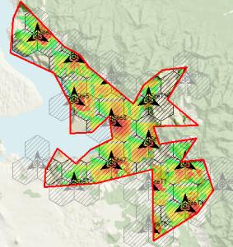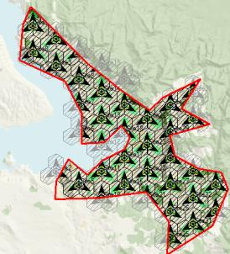
Gambar 10. Hasil simulasi RSRP Kabupaten Toba Samosir; LTE-A 850MHz (kiri), LTE 1800MHz (Kanan)

- Active User dan Effective Throughput

  - Jakarta pusat, LTE 850 MHz

Site | Peak RLC Cumulated Throughput (DL) (kbps) | Effective RLC Cumulated Throughput (DL) (kbps) | Cumulated Application Throughput (DL) (kbps) | Peak RLC Cumulated Throughput (UL) (kbps) | Effective RLC Cumulated Throughput (UL) (kbps) | Cumulated Application Throughput (UL) (kbps) | Connection Success Rate (%)
Site0 | 68,388.70 | 68,264 | 67,190.80 | 44,992.60 | 44,992.60 | 43,892.80 | 100
Site1 | 39,392.30 | 39,260.40 | 38,710.60 | 31,104.80 | 31,104.80 | 30,307.30 | 99.65
Site2 | 99,112.90 | 98,560.30 | 96,812.30 | 101,184 | 101,184 | 98,754.70 | 98.47
Site3 | 60,203.60 | 60,093.70 | 59,142.20 | 43,712.60 | 43,712.60 | 42,621.80 | 98.78

  - Jakarta pusat, LTE 1800 MHz

Site | Peak RLC Cumulated Throughput (DL) (kbps) | Effective RLC Cumulated Throughput (DL) (kbps) | Cumulated Application Throughput (DL) (kbps) | Peak RLC Cumulated Throughput (UL) (kbps) | Effective RLC Cumulated Throughput (UL) (kbps) | Cumulated Application Throughput (UL) (kbps) | Connection Success Rate (%)
Site0 | 25,251.10 | 25,130 | 24,803.20 | 14,592.40 | 14,567.30 | 14,237.80 | 97.64
Site1 | 32,922.30 | 32,814.20 | 32,358.60 | 18,752.50 | 18,717.50 | 18,233.80 | 96.32
Site10 | 26,285.90 | 26,249.80 | 25,889.30 | 11,136 | 11,113 | 10,817.80 | 95.85
Site11 | 10,824.20 | 10,789.80 | 10,660.40 | 6,208.19 | 6,184.70 | 6,056.59 | 96.63
Site12 | 6,392.53 | 6,376.70 | 6,298.52 | 2,560.04 | 2,551.98 | 2,475.40 | 86.44
Site2 | 45,492.90 | 45,111.10 | 44,514.70 | 31,872.90 | 31,814.80 | 31,062.50 | 90.79
Site3 | 41,122.80 | 40,771.20 | 40,200.80 | 30,592.70 | 30,532.30 | 29,716.20 | 89.27
Site4 | 34,618.40 | 34,385.70 | 33,908.10 | 17,216.50 | 17,178.30 | 16,766.30 | 94.52
Site5 | 38,521.90 | 37,871.30 | 37,331.70 | 38,785 | 38,716 | 37,684.70 | 87.64
Site6 | 50,097.30 | 49,483.70 | 48,827.30 | 39,425 | 39,327.50 | 38,295.80 | 91.11
Site7 | 35,695 | 35,234.60 | 34,710.10 | 28,480.80 | 28,420.20 | 27,717.10 | 91.69
Site8 | 38,675.60 | 38,156.60 | 37,646.30 | 35,009 | 34,964.60 | 34,134.10 | 89.59
Site9 | 30,551.30 | 30,379.60 | 29,998.40 | 18,752.50 | 18,719.50 | 18,235.50 | 95.97

  - Kota Bandung, LTE 850 MHz
Site | Peak RLC Cumulated Throughput (DL) (kbps) | Effective RLC Cumulated Throughput (DL) (kbps) | Cumulated Application Throughput (DL) (kbps) | Peak RLC Cumulated Throughput (UL) (kbps) | Effective RLC Cumulated Throughput (UL) (kbps) | Cumulated Application Throughput (UL) (kbps) | Connection Success Rate (%)
Site0 | 95,497.10 | 94,998 | 93,441.90 | 96,320.90 | 96,320.90 | 93,768.80 | 93.31
Site1 | 110,297.00 | 110,034.00 | 108,174.00 | 99,265.10 | 99,265.10 | 96,693.40 | 99.64
Site2 | 36,207.20 | 35,971.10 | 35,305.00 | 38,784 | 38,784 | 37,767.10 | 97.09
Site3 | 94,436.00 | 93,924.20 | 92,229.70 | 101,185.00 | 101,185.00 | 98,606.10 | 96.28
Site4 | 93,153.20 | 92,432.90 | 91,111.40 | 94,592.90 | 94,592.90 | 92,381.70 | 88.71
Site5 | 37,392.20 | 37,360.50 | 36,900.50 | 11,904.30 | 11,904.30 | 11,606.10 | 100
Site6 | 25,472.00 | 25,472.00 | 25,171.20 | 10,432.30 | 10,432.30 | 10,179.50 | 100

  - Kota Bandung, LTE 1800 MHz
Site | Peak RLC Cumulated Throughput (DL) (kbps) | Effective RLC Cumulated Throughput (DL) (kbps) | Cumulated Application Throughput (DL) (kbps) | Peak RLC Cumulated Throughput (UL) (kbps) | Effective RLC Cumulated Throughput (UL) (kbps) | Cumulated Application Throughput (UL) (kbps) | Connection Success Rate (%)
Site0 | 32,443.60 | 32,311 | 31,951.80 | 14,464.30 | 14,388.50 | 14,025.60 | 98.14
Site1 | 25,244.30 | 25,106.90 | 24,825.60 | 9,920.26 | 9,880.46 | 9,628.70 | 100
Site10 | 69,687.90 | 68,896.00 | 68,085.30 | 52,097 | 51,971 | 50,628.50 | 89.81
Site11 | 66,790.70 | 66,009.80 | 65,182.30 | 53,313.30 | 53,184.70 | 51,774.10 | 88.01
Site12 | 27,020.80 | 26,913.00 | 26,595.60 | 13,504.30 | 13,438.10 | 13,079.30 | 96.78
Site13 | 35,311.00 | 35,054.20 | 34,652.20 | 14,080.40 | 14,028.70 | 13,684.40 | 97.82
Site14 | 75,555.80 | 74,579.00 | 73,666.80 | 55,361.30 | 55,209.90 | 53,774.60 | 89.22
Site15 | 46,756.10 | 46,540.90 | 46,004.40 | 25,600.60 | 25,521.10 | 24,857.30 | 96.25
Site16 | 55,426.90 | 54,742.60 | 54,048.60 | 39,681 | 39,550 | 38,485.20 | 87.62
Site17 | 62,680.70 | 62,204.90 | 61,464.50 | 44,929 | 44,773.00 | 43,554.30 | 86.85
Site18 | 33,134 | 33,007.10 | 32,628.40 | 17,600.40 | 17,532.50 | 17,040.90 | 97.01
Site2 | 59,299.90 | 58,663.60 | 57,969.40 | 47,937 | 47,798.70 | 46,610.50 | 86.48
Site3 | 69,966.10 | 69,181.30 | 68,332.40 | 51,905.30 | 51,750.10 | 50,405.90 | 90.32
Site4 | 42,638.50 | 42,088.10 | 41,575.90 | 31,232.80 | 31,129.10 | 30,322.50 | 91.96
Site5 | 49,848.40 | 49,291 | 48,694.50 | 33,792.80 | 33,692.60 | 32,778.80 | 91.65
Site6 | 79,111 | 78,256.60 | 77,317.70 | 55,937.40 | 55,775.70 | 54,365.30 | 87.74
Site7 | 74,616.60 | 73,752.40 | 72,871.10 | 55,297.40 | 55,100.10 | 53,676.80 | 86.6
Site8 | 42,875.20 | 42,374.80 | 41,857.30 | 27,776.70 | 27,653.30 | 26,983.80 | 94.31
Site9 | 17,397.70 | 17,344.60 | 17,156.30 | 8,320.25 | 8,283.20 | 8,073.06 | 100

  - Kabupaten Banyumas, LTE 850 MHz
Site | Peak RLC Cumulated Throughput (DL) (kbps) | Effective RLC Cumulated Throughput (DL) (kbps) | Cumulated Application Throughput (DL) (kbps) | Peak RLC Cumulated Throughput (UL) (kbps) | Effective RLC Cumulated Throughput (UL) (kbps) | Cumulated Application Throughput (UL) (kbps) | Connection Success Rate (%)
Site0 | 16,584.60 | 16,561 | 16,357.40 | 6,208.13 | 6,188.67 | 6,014.53 | 100
Site1 | 56,690.50 | 56,633.20 | 55,900.10 | 24,000.60 | 23,986.50 | 23,342.30 | 98.25
Site10 | 26,535.00 | 26,503.70 | 26,165.50 | 12,224 | 12,224 | 11,912.60 | 99.07
Site11 | 64,241.70 | 64,024.80 | 63,180.80 | 31,616.80 | 31,582.40 | 30,790.90 | 95.48
Site12 | 85,324.80 | 85,203.10 | 84,111.40 | 41,089.00 | 41,062.90 | 39,997.20 | 97.97
Site13 | 65,608.60 | 65,428.80 | 64,630.70 | 31,360.70 | 31,301.70 | 30,447.20 | 98.9
Site14 | 51,829.30 | 51,669.80 | 50,979.10 | 24,896.70 | 24,825.40 | 24,204.60 | 99.57
Site15 | 36,973.70 | 36,659.60 | 36,150.10 | 25,664.70 | 25,631.50 | 24,960.90 | 97.35
Site16 | 86,096.10 | 85,727.10 | 84,677.30 | 39,041 | 39,026 | 38,006.00 | 97.39
Site17 | 93,701.30 | 93,474.60 | 92,260.30 | 46,913 | 46,911.60 | 45,679.50 | 96.5
Site18 | 42,222 | 42,065.90 | 41,557.10 | 20,928.60 | 20,915.10 | 20,388.70 | 92.38
Site19 | 71,276.60 | 71,191.00 | 70,259.50 | 34,049 | 34,043.30 | 33,170.40 | 96.3
Site2 | 72,221.60 | 71,849.10 | 70,953.30 | 31,873.00 | 31,775.00 | 31,018.40 | 98.7
Site20 | 89,514.40 | 89,335.00 | 88,217.10 | 39,169.10 | 39,158.00 | 38,182.70 | 94.96
Site21 | 43,389.80 | 43,245 | 42,707.80 | 18,240.40 | 18,240.40 | 17,796.90 | 96.3
Site22 | 26,472 | 26,464.60 | 26,138.50 | 9,984.23 | 9,984.23 | 9,735.91 | 99.45
Site23 | 71,658.40 | 71,365.70 | 70,408.50 | 35,264.90 | 35,161.00 | 34,242.60 | 96.62
Site24 | 21,205.20 | 21,151.60 | 20,876.10 | 10,048.30 | 10,048.30 | 9,809.53 | 96.35
Site3 | 77,760.40 | 77,539.50 | 76,494.40 | 35,905.00 | 35,896.50 | 35,005.10 | 97.15
Site4 | 80,453.20 | 80,247.70 | 79,232.90 | 41,537 | 41,466 | 40,335.60 | 98.1
Site5 | 56,185.30 | 55,996.40 | 55,324.90 | 26,368.70 | 26,311.70 | 25,675.70 | 96.65
Site6 | 51,641.60 | 51,505.60 | 50,913.80 | 25,920.70 | 25,920.70 | 25,241.60 | 98.03
Site7 | 77,703.40 | 77,479.90 | 76,485.10 | 37,952.90 | 37,922.40 | 36,929.20 | 96.85
Site8 | 101,831 | 101,489 | 100,207 | 46,721.20 | 46,680.70 | 45,497.50 | 94.62
Site9 | 45,854.30 | 45,620.10 | 45,046.50 | 21,312.50 | 21,221 | 20,626.40 | 100

  - Kabupaten Banyumas, LTE 1800 MHz
Site | Peak RLC Cumulated Throughput (DL) (kbps) | Effective RLC Cumulated Throughput (DL) (kbps) | Cumulated Application Throughput (DL) (kbps) | Peak RLC Cumulated Throughput (UL) (kbps) | Effective RLC Cumulated Throughput (UL) (kbps) | Cumulated Application Throughput (UL) (kbps) | Connection Success Rate (%)
Site0 | 12,179.60 | 12,095 | 11,959.60 | 8,512.18 | 8,469.98 | 8,206.85 | 100
Site1 | 5,850.07 | 5,806.49 | 5,738.69 | 7,168.18 | 7,122.54 | 6,939.44 | 100
Site10 | 10,930.20 | 10,823.90 | 10,709.80 | 5,056 | 5,021 | 4,889.18 | 98.95
Site11 | 21,816.80 | 21,571.40 | 21,316.20 | 15,232.30 | 15,128.90 | 14,718.40 | 98.79
Site12 | 14,075.80 | 13,989.10 | 13,816.00 | 10,112.30 | 10,046.80 | 9,819.17 | 100
Site13 | 19,989.20 | 19,828.50 | 19,584.20 | 13,056.30 | 12,982.10 | 12,633.70 | 99.12
Site14 | 9,297.85 | 9,243.66 | 9,130.74 | 6,336.18 | 6,309.02 | 6,154.06 | 100
Site15 | 8,772.45 | 8,621.05 | 8,530.97 | 2,816.09 | 2,800.83 | 2,737.24 | 100
Site16 | 22,415.90 | 22,280.00 | 22,018.10 | 11,200 | 11,134 | 10,860.30 | 99.53
Site17 | 21,076.50 | 20,903.60 | 20,658.80 | 9,792 | 9,735.23 | 9,515.59 | 99.47
Site18 | 10,129 | 10,035.40 | 9,917.34 | 8,064.17 | 8,032.79 | 7,809.71 | 100
Site19 | 14,843.10 | 14,693.70 | 14,514.50 | 14,336 | 14,261.10 | 13,879.20 | 100
Site2 | 12,158.90 | 12,090.70 | 11,941.70 | 10,304.20 | 10,249.20 | 9,978.38 | 100
Site20 | 15,893.30 | 15,600.70 | 15,422.00 | 12,672.30 | 12,603.50 | 12,273.70 | 100
Site21 | 0.00 | 0 | 0.00 | 0.00 | 0.00 | 0.00
Site22 | 21,412 | 21,207.50 | 20,978.20 | 12,352.30 | 12,267.40 | 11,916.10 | 100
Site23 | 21,258.80 | 21,052.30 | 20,824.80 | 12,800.30 | 12,726.50 | 12,395.60 | 99.55
Site24 | 16,037.90 | 15,900.30 | 15,714.00 | 10,496.20 | 10,437.30 | 10,165.00 | 98.91
Site25 | 15,841.10 | 15,683.70 | 15,499.10 | 12,736.30 | 12,668.80 | 12,333.00 | 99.54
Site26 | 16,381.90 | 16,274.60 | 16,088.70 | 10,816 | 10,755 | 10,500.00 | 100
Site27 | 12,982.70 | 12,768.20 | 12,619.00 | 6,976.17 | 6,948.26 | 6,771.72 | 100
Site28 | 2,432.27 | 2,312.17 | 2,286.96 | 1,536.03 | 1,528.89 | 1,483.15 | 100
Site29 | 19,196.10 | 18,958.50 | 18,726.50 | 9,088.22 | 9,048.66 | 8,805.11 | 99.41
Site3 | 1,855 | 1,843 | 1,820 | 2,496.07 | 2,488.33 | 2,422.56 | 100
Site30 | 18,537.00 | 18,254.30 | 18,025.80 | 11,392.30 | 11,321 | 11,055.60 | 100
Site31 | 8,747.68 | 8,670.26 | 8,568.20 | 4,544.11 | 4,530.23 | 4,423.67 | 100
Site32 | 17,596.30 | 17,474.30 | 17,253.50 | 11,776.30 | 11,702.80 | 11,392.40 | 99.5
Site33 | 16,219 | 16,013.30 | 15,804.50 | 10,304.30 | 10,243.70 | 10,008.90 | 99.5
Site34 | 12,694 | 12,639 | 12,502.80 | 8,064.17 | 8,014.44 | 7,796.99 | 100
Site35 | 9,941.30 | 9,768.92 | 9,657.26 | 7,424.20 | 7,378.18 | 7,192.18 | 100
Site36 | 6,141.05 | 6,096 | 6,029.92 | 3,648.11 | 3,630.13 | 3,537.63 | 100
Site37 | 23,133.30 | 22,787.70 | 22,501.70 | 13,760.30 | 13,670.90 | 13,279.90 | 98.04
Site38 | 7,976.93 | 7,907.79 | 7,813.35 | 7,232.19 | 7,196.10 | 7,022.08 | 100
Site39 | 23,125.30 | 22,950.40 | 22,675.20 | 11,584.30 | 11,524.40 | 11,266.80 | 98.28
Site4 | 10,583.50 | 10,555.30 | 10,438.10 | 12,288.30 | 12,221.70 | 11,911.10 | 100
Site40 | 30,109.40 | 29,729.80 | 29,389.80 | 12,992.30 | 12,942.90 | 12,614.50 | 99.22
Site41 | 21,908.10 | 21,677.40 | 21,417 | 10,816.30 | 10,739.80 | 10,485.10 | 99.53
Site42 | 17,206.60 | 16,990 | 16,784.50 | 12,096.30 | 12,018 | 11,714.70 | 98.6
Site43 | 4,898.76 | 4,838.24 | 4,782.18 | 3,904.10 | 3,884.41 | 3,784.40 | 100
Site44 | 6,628.31 | 6,584.04 | 6,496.38 | 4,800.13 | 4,774.77 | 4,681.13 | 100
Site45 | 14,024 | 13,921.20 | 13,732.40 | 10,688.20 | 10,625.50 | 10,351.40 | 100
Site46 | 18,549.80 | 18,378.80 | 18,147.10 | 11,712.30 | 11,636.90 | 11,393.50 | 99.54
Site47 | 21,894.10 | 21,665.50 | 21,417.70 | 13,824.40 | 13,755.40 | 13,408.80 | 99.23
Site48 | 21,137 | 20,943.70 | 20,697.10 | 12,992.30 | 12,920.20 | 12,607.50 | 99.16
Site49 | 14,367.60 | 14,303.10 | 14,126.80 | 6,400.16 | 6,366.02 | 6,205.51 | 100
Site5 | 20,641.60 | 20,530 | 20,276.50 | 10,816.30 | 10,759.30 | 10,483.70 | 99.49
Site50 | 16,065.70 | 15,826.30 | 15,638.70 | 11,712.30 | 11,651.50 | 11,346.30 | 100
Site51 | 17,099.30 | 17,021.80 | 16,816 | 11,456.30 | 11,409 | 11,111.40 | 100
Site52 | 21,777 | 21,640.30 | 21,385 | 12,800.40 | 12,723.70 | 12,433.70 | 99.57
Site53 | 25,434.30 | 25,108.10 | 24,813.60 | 14,016.40 | 13,945.60 | 13,617.80 | 99.62
Site54 | 12,185 | 12,070.40 | 11,923.40 | 6,656.20 | 6,619.19 | 6,461.04 | 100
Site55 | 11,869.30 | 11,762.40 | 11,621.30 | 6,208.17 | 6,170.46 | 6,022.27 | 99.14
Site56 | 8,549.06 | 8,479.64 | 8,382.25 | 6,272.16 | 6,245.76 | 6,096.54 | 100
Site57 | 17,757 | 17,603.90 | 17,399.90 | 11,968.30 | 11,906.70 | 11,563.50 | 98.98
Site58 | 14,705.60 | 14,630.10 | 14,462.60 | 6,272.18 | 6,250.21 | 6,106.20 | 99.21
Site59 | 22,228.30 | 22,004.50 | 21,737.50 | 12,288.30 | 12,203.40 | 11,883.10 | 97.91
Site6 | 5,685.76 | 5,643.32 | 5,576.64 | 4,352.11 | 4,324.81 | 4,210.33 | 100
Site60 | 10,087.40 | 10,017.50 | 9,909.69 | 5,440.13 | 5,414.62 | 5,284.11 | 100
Site61 | 4,337 | 4,255.21 | 4,190.58 | 2,688.06 | 2,667.39 | 2,599.95 | 100
Site62 | 10,516.80 | 10,414.40 | 10,283.50 | 7,424.17 | 7,378.51 | 7,172.39 | 100
Site63 | 13,321.50 | 13,085.10 | 12,930.40 | 11,520.30 | 11,463.50 | 11,165.30 | 100
Site64 | 4,067.13 | 4,036.71 | 3,996.34 | 2,880.07 | 2,868.18 | 2,798.64 | 100
Site65 | 7,143.03 | 7,088.55 | 6,996.15 | 4,480.10 | 4,457.81 | 4,336.80 | 100
Site7 | 9,377 | 9,337.53 | 9,232.98 | 5,632.16 | 5,601.20 | 5,473.95 | 100
Site8 | 21,636.70 | 21,438.50 | 21,188.40 | 13,504.40 | 13,410.50 | 13,082.90 | 98.4
Site9 | 8,451.52 | 8,372.49 | 8,261.87 | 7,488.16 | 7,448.10 | 7,251.25 | 100

  - Kabupaten Toba Samosir, LTE 850 MHz
Site | Peak RLC Cumulated Throughput (DL) (kbps) | Effective RLC Cumulated Throughput (DL) (kbps) | Cumulated Application Throughput (DL) (kbps) | Peak RLC Cumulated Throughput (UL) (kbps) | Effective RLC Cumulated Throughput (UL) (kbps) | Cumulated Application Throughput (UL) (kbps) | Connection Success Rate (%)
Site0 | 330.18 | 322 | 318.62 | 320.01 | 316.88 | 313.71 | 100
Site10 | 8,974.87 | 8,964.80 | 8,862.50 | 4,352.08 | 4,339.89 | 4,214.86 | 100
Site11 | 21,195.50 | 21,128.10 | 20,873.30 | 9,472 | 9,462 | 9,213.70 | 100
Site12 | 30,312.40 | 30,168.50 | 29,798.10 | 14,848.40 | 14,838.10 | 14,469.80 | 98.18
Site13 | 17,420.50 | 17,354.70 | 17,148.40 | 11,136.30 | 11,092.90 | 10,824.00 | 100
Site14 | 40,724.70 | 40,521.90 | 40,048.90 | 14,528.40 | 14,512.10 | 14,193.30 | 97.67
Site15 | 38,823.40 | 38,715.60 | 38,256.60 | 18,304.50 | 18,284.10 | 17,819.90 | 98.82
Site16 | 5,551.31 | 5,419.34 | 5,354.94 | 3,136.05 | 3,107.94 | 3,010.88 | 100
Site17 | 6,330.16 | 6,301.05 | 6,227.80 | 3,904 | 3,892 | 3,776.91 | 100
Site2 | 32,008.20 | 31,784.50 | 31,442.80 | 17,792 | 17,750.90 | 17,297.80 | 98.42
Site3 | 12,706 | 12,607.90 | 12,467.70 | 7,808.22 | 7,779.28 | 7,594.45 | 100
Site5 | 33,356.00 | 33,255.90 | 32,882.40 | 14,912 | 14,885.90 | 14,532.80 | 100
Site6 | 21,397.70 | 21,347.60 | 21,088.10 | 12,544.30 | 12,525.30 | 12,195.50 | 99.07
Site7 | 36,501.40 | 36,405.40 | 35,990.20 | 21,184.50 | 21,175.30 | 20,590.00 | 99.41
Site8 | 40,992.80 | 40,956 | 40,495.00 | 17,856.50 | 17,854.40 | 17,445.50 | 99.69
Site9 | 11,729 | 11,726.80 | 11,589.00 | 6,784.23 | 6,779.23 | 6,649.99 | 100

  - Kabupaten Toba Samosir, LTE 1800 MHz
Site | Peak RLC Cumulated Throughput (DL) (kbps) | Effective RLC Cumulated Throughput (DL) (kbps) | Cumulated Application Throughput (DL) (kbps) | Peak RLC Cumulated Throughput (UL) (kbps) | Effective RLC Cumulated Throughput (UL) (kbps) | Cumulated Application Throughput (UL) (kbps) | Connection Success Rate (%)
Site0 | 6,393.57 | 6,350 | 6,246.05 | 2,624.06 | 2,613.16 | 2,551.27 | 100
Site1 | 9,381.43 | 9,245.15 | 9,051.34 | 5,184.10 | 5,155.56 | 4,996.96 | 100
Site10 | 1,739.97 | 1,737.96 | 1,720.58 | 384 | 383 | 374.00 | 100
Site11 | 10,635.00 | 10,635.00 | 10,418.40 | 7,104.20 | 7,061.43 | 6,899.22 | 100
Site12 | 3,095.61 | 3,039.99 | 3,009.59 | 3,456.08 | 3,433.03 | 3,327.39 | 100
Site13 | 11,949.70 | 11,898.30 | 11,605.70 | 6,144.18 | 6,114.47 | 5,987.16 | 100
Site14 | 15,230.80 | 15,069.50 | 14,686.60 | 6,592.17 | 6,550.33 | 6,383.17 | 100
Site15 | 2,360.82 | 2,356.04 | 2,332.48 | 1,408.03 | 1,398.68 | 1,369.37 | 100
Site16 | 13,191.20 | 12,994.70 | 12,843.90 | 5,440 | 5,411 | 5,275.63 | 100
Site17 | 11,152.60 | 10,936.80 | 10,769.60 | 5,824 | 5,795.74 | 5,666.40 | 100
Site18 | 7,711 | 7,675.32 | 7,473.76 | 2,304.07 | 2,296.75 | 2,243.06 | 100
Site19 | 16,998.70 | 16,736.00 | 16,317.30 | 7,104 | 7,057.63 | 6,859.99 | 100
Site2 | 604.81 | 604.81 | 598.76 | 384.01 | 380.76 | 371.92 | 100
Site20 | 2,388.70 | 2,370.40 | 2,305.74 | 768.02 | 764.76 | 746.87 | 100
Site21 | 2,389.34 | 2,374 | 2,309.11 | 2,240.07 | 2,225.78 | 2,172.97 | 100
Site22 | 13,409 | 13,309.50 | 13,010.70 | 6,656.16 | 6,608.19 | 6,455.72 | 100
Site23 | 13,386.30 | 13,236.30 | 13,044.60 | 7,488.19 | 7,448.25 | 7,241.31 | 99.27
Site24 | 8,100.66 | 8,014.34 | 7,840.52 | 6,272.18 | 6,236.62 | 6,087.65 | 100
Site25 | 2,359.08 | 2,352.82 | 2,300.51 | 1,984.03 | 1,976.60 | 1,926.21 | 100
Site26 | 7,650.17 | 7,596.86 | 7,427.01 | 3,840 | 3,820 | 3,710.11 | 100
Site27 | 5,822.53 | 5,793.18 | 5,644.13 | 4,928.11 | 4,898.14 | 4,757.57 | 100
Site28 | 4,497.34 | 4,400.26 | 4,299.47 | 2,624.04 | 2,614.68 | 2,532.42 | 100
Site29 | 8,180.75 | 8,044.16 | 7,785.22 | 2,752.05 | 2,735.10 | 2,651.84 | 100
Site3 | 5,333 | 5,227 | 5,105 | 1,920.05 | 1,913.53 | 1,858.66 | 100
Site30 | 2,880.45 | 2,878.99 | 2,841.53 | 896.00 | 896 | 866.56 | 100
Site31 | 10,019.00 | 9,926.32 | 9,766.57 | 6,656.15 | 6,626.25 | 6,473.40 | 100
Site32 | 7,722.95 | 7,610.34 | 7,523.78 | 6,272.18 | 6,232.33 | 6,098.78 | 100
Site33 | 7,866 | 7,838.04 | 7,681.25 | 3,136.08 | 3,114.81 | 3,037.94 | 100
Site34 | 2,642 | 2,572 | 2,515.55 | 2,048.02 | 2,040.14 | 1,968.78 | 100
Site35 | 3,288.04 | 3,173.98 | 3,101.28 | 320.01 | 316.32 | 308.09 | 100
Site36 | 3,568.98 | 3,553 | 3,476.83 | 1,984.05 | 1,972.05 | 1,911.71 | 100
Site37 | 7,316.60 | 7,250.31 | 7,160.47 | 6,208.16 | 6,172.58 | 6,019.12 | 100
Site4 | 5,216.79 | 5,208.11 | 5,145.14 | 3,008.07 | 2,996.20 | 2,915.20 | 100
Site5 | 6,509.75 | 6,356.17 | 6,256.49 | 4,160.10 | 4,135.49 | 4,017.89 | 100
Site6 | 1,058.39 | 1,036.20 | 1,025.84 | 320.01 | 319.05 | 310.74 | 100
Site7 | 2,264.85 | 2,237.37 | 2,215.00 | 1,664.02 | 1,654.80 | 1,597.61 | 100
Site8 | 6,866.92 | 6,772.61 | 6,665 | 3,904.09 | 3,884.99 | 3,769.70 | 100
Site9 | 4,165.24 | 4,124 | 4,040.66 | 2,752.07 | 2,729 | 2,650.94 | 100

